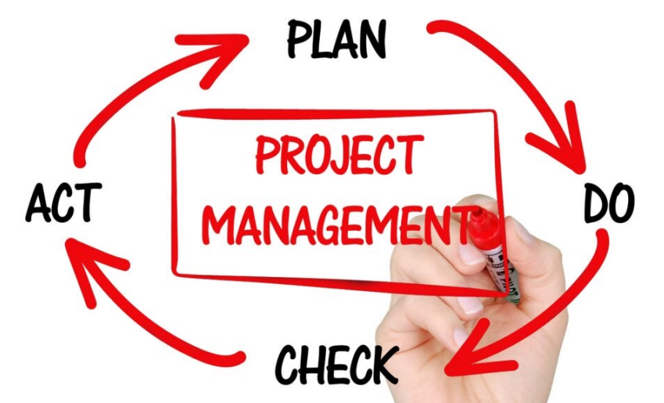
Phases of a project
- Initiation
- Planning
- Implementation
- Closing

Initiation phase
- The project sponsor is identified
- Scope and deliverables are defined
  - Relationship to organizational goals is key
- Budget is approved
- Broad statements are made about risks, approaches, timelines
- Stakeholders are identified
- The project Manager is assigned
- At the end of a phase, an approved project charter is the approval to proceed to the planning phase

Planning phase
- Deliverables are clearly defined
- Based on the deliverables, a work breakdown structure or WBS defines the “work packages”
- The work packages are used to develop a schedule
- Plans are made for the management of stakeholders, communication, quality, costs, risks, procurement, and resources including human resources

Implementation (Execution) Phase
- The project team is hired and developed
- Procurements take place
- Project work is underway
- Project must be monitored and changes managed
- Communication with stakeholders is an important ongoing activity

Closing phase
- Reporting
- Closing out procurements—final payments
- Identify lessons learned
- Celebrate

Summary
- Project Phases
- Initiation
- Planning
- Implementation (Execution)
- Closing

